XFT BGP Capstone – Design Decisions (v2.4)
This doc holds the XFT capstone design. The current design (v2.4) comes first; earlier versions (v1.2 and v2.0) are kept at the end for history. Where they disagree, v2.4 wins.

Topology (v2.2)
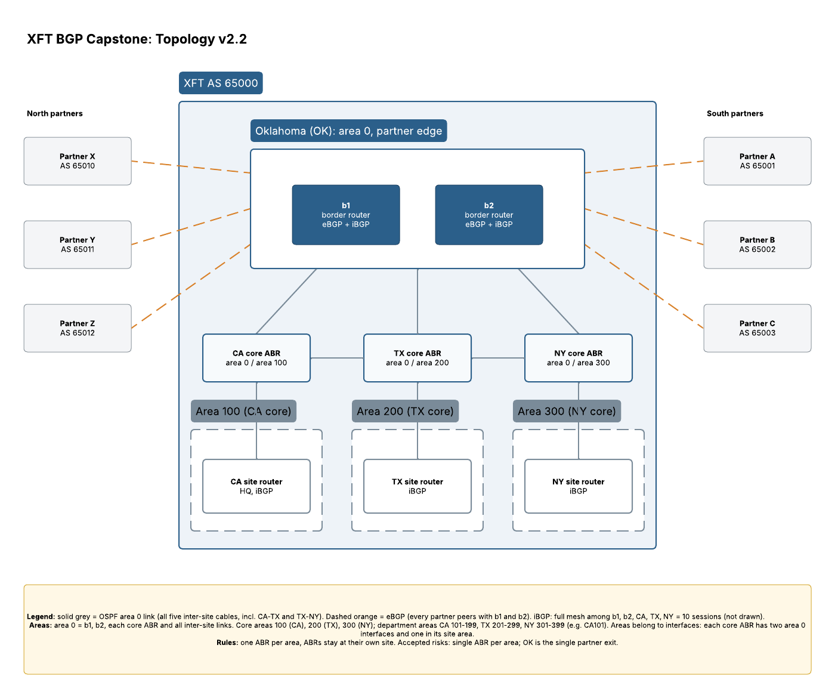
Figure 3: XFT topology v2.2. Core areas 100/200/300, one core ABR per site, every inter-site cable in area 0. Editable in Lucid: XFT BGP Capstone – Topology v2.2.

Sites
- Branch sites: California (CA, headquarters), Texas (TX), New York (NY).
- Partner edge: Oklahoma (OK) hosts the border routers b1 and b2, which run eBGP to all six partners and iBGP to the sites.
- XFT is one autonomous system, AS 65000.

Physical layer (cables)
One link between each connected pair of sites for now. Redundant links are a separate future sub-project.
Link | Ends | OSPF area
CA – TX | CA ABR – TX ABR | Area 0
TX – NY | TX ABR – NY ABR | Area 0
CA – OK | CA ABR – OK | Area 0
TX – OK | TX ABR – OK | Area 0
NY – OK | NY ABR – OK | Area 0
Every link between sites is in area 0.

OSPF areas
- Area 0 is the single backbone. It is not a building: it is the set of backbone links (all five cables above) plus b1, b2, and each site's ABR.
- Every other area attaches directly to area 0 through an ABR. Areas never touch each other.
- Areas belong to interfaces, not whole routers. An ABR has some interfaces in area 0 and one in its own area.

Area numbering (replaces areas 1–3 from v2.1)
Each site owns one block of 100 area numbers. The first number in each block is the site's core area, where the site's iBGP router sits. The rest are for departments.
Site | Core area | Department areas
California | 100 | 101–199
Texas | 200 | 201–299
New York | 300 | 301–399
Department areas are named by site plus area number, for example CA101, TX201, NY301.

ABRs
- ABRs stay local to their own site, never in Oklahoma. This keeps each site's LSA flooding local; only summaries cross the long-haul links.
- Rule (v2.4): one ABR per site. Each site ABR serves the site's core area and all of its department areas. This replaces the v2.2 rule of one ABR per area, which would have added an ABR, and its BGP sessions, for every new department.
- Cost: if a site ABR fails, the whole site (core area and every department) is cut off. Accepted for now; a second ABR per site is future work.
- Example, Texas ABR (tx-abr-200): one interface in core area 200, interfaces in each Texas department area (201–299), one area 0 interface up to Oklahoma, and one area 0 interface across to the New York ABR.

Department areas: totally stubby (v2.4)
Every department area (101–199, 201–299, 301–399) is totally stubby: its routers see only their own area plus one default route pointing to the site ABR.
- Why a default: OSPF Type 3 summaries only cover XFT's internal prefixes, never partner routes. A department router has one way out, so it only needs to know "out", not every partner prefix.
- Who originates it: the site ABR injects the default automatically, because the area is totally stubby. Nothing is redistributed from BGP into OSPF, so no router is an ASBR.
- The ABR still knows the details: it is an RR client with the full partner table, and makes the per-prefix choice for the whole site.
- Core areas (100, 200, 300) stay normal areas. The site router's BGP next hops (b1 and b2 loopbacks) must resolve through real OSPF routes, not a default.
Alternative considered: conditional default from b1 and b2, no BGP on the ABRs. b1 and b2 would inject a default into area 0, sent only while they still hold partner routes. Common in enterprises, and fewer BGP sessions. Rejected because sites could not choose the best exit per prefix, and this capstone is meant to practice iBGP the way providers and large clouds run it.

Routers (v2.3)
Router | Role | Site | OSPF area(s) | AS | Loopback / router ID
ca-ibgp-100 | Site router, RR client | CA | 100 | 65000 | 10.255.0.1/32
tx-ibgp-200 | Site router, RR client | TX | 200 | 65000 | 10.255.0.2/32
ny-ibgp-300 | Site router, RR client | NY | 300 | 65000 | 10.255.0.3/32
ca-abr-100 | Site ABR, RR client | CA | 100, 101–199 / 0 | 65000 | 10.255.0.11/32
tx-abr-200 | Site ABR, RR client | TX | 200, 201–299 / 0 | 65000 | 10.255.0.12/32
ny-abr-300 | Site ABR, RR client | NY | 300, 301–399 / 0 | 65000 | 10.255.0.13/32
ok-core-000 | Backbone router, route reflector 1 | OK | 0 | 65000 | 10.255.0.20/32
(name TBD) | Backbone router, route reflector 2 | OK | 0 | 65000 | TBD
ok-border-000 | Border router (b1), RR client | OK | 0 | 65000 | 10.255.0.21/32
ok-border-001 | Border router (b2), RR client | OK | 0 | 65000 | 10.255.0.22/32
a-ebgp-65001 | Partner edge router | Partner A | - | 65001 | TBD
b-ebgp-65002 | Partner edge router | Partner B | - | 65002 | TBD
c-ebgp-65003 | Partner edge router | Partner C | - | 65003 | TBD
x-ebgp-65010 | Partner edge router | Partner X | - | 65010 | TBD
y-ebgp-65011 | Partner edge router | Partner Y | - | 65011 | TBD
z-ebgp-65012 | Partner edge router | Partner Z | - | 65012 | TBD
ok-core-000 is a backbone router, not an ABR: every interface on it is in area 0. iBGP sessions run between loopbacks, which OSPF advertises.

Links (v2.3)
# | Source | Src int | Destination | Dst int | Subnet | OSPF area | Type
1 | ca-ibgp-100 | eth1 | ca-abr-100 | eth1 | 10.0.0.0/30 | 100 | Inside CA
2 | tx-ibgp-200 | eth1 | tx-abr-200 | eth1 | 10.0.0.4/30 | 200 | Inside TX
3 | ny-ibgp-300 | eth1 | ny-abr-300 | eth1 | 10.0.0.8/30 | 300 | Inside NY
4 | ca-abr-100 | eth2 | tx-abr-200 | eth2 | 10.0.0.12/30 | 0 | CA – TX cable
5 | tx-abr-200 | eth3 | ny-abr-300 | eth2 | 10.0.0.16/30 | 0 | TX – NY cable
6 | ca-abr-100 | eth3 | ok-core-000 | eth1 | 10.0.0.20/30 | 0 | CA – OK cable
7 | tx-abr-200 | eth4 | ok-core-000 | eth2 | 10.0.0.24/30 | 0 | TX – OK cable
8 | ny-abr-300 | eth3 | ok-core-000 | eth3 | 10.0.0.28/30 | 0 | NY – OK cable
9 | ok-core-000 | eth4 | ok-border-000 | eth1 | 10.0.0.32/30 | 0 | Inside OK
10 | ok-core-000 | eth5 | ok-border-001 | eth1 | 10.0.0.36/30 | 0 | Inside OK
11 | ok-border-000 | eth2 | a-ebgp-65001 | eth1 | 172.16.0.0/30 | - | eBGP
12 | ok-border-001 | eth2 | a-ebgp-65001 | eth2 | 172.16.0.4/30 | - | eBGP
13 | ok-border-000 | eth3 | b-ebgp-65002 | eth1 | 172.16.0.8/30 | - | eBGP
14 | ok-border-001 | eth3 | b-ebgp-65002 | eth2 | 172.16.0.12/30 | - | eBGP
15 | ok-border-000 | eth4 | c-ebgp-65003 | eth1 | 172.16.0.16/30 | - | eBGP
16 | ok-border-001 | eth4 | c-ebgp-65003 | eth2 | 172.16.0.20/30 | - | eBGP
17 | ok-border-000 | eth5 | x-ebgp-65010 | eth1 | 172.16.0.24/30 | - | eBGP
18 | ok-border-001 | eth5 | x-ebgp-65010 | eth2 | 172.16.0.28/30 | - | eBGP
19 | ok-border-000 | eth6 | y-ebgp-65011 | eth1 | 172.16.0.32/30 | - | eBGP
20 | ok-border-001 | eth6 | y-ebgp-65011 | eth2 | 172.16.0.36/30 | - | eBGP
21 | ok-border-000 | eth7 | z-ebgp-65012 | eth1 | 172.16.0.40/30 | - | eBGP
22 | ok-border-001 | eth7 | z-ebgp-65012 | eth2 | 172.16.0.44/30 | - | eBGP
eth0 is containerlab's management interface, so data links start at eth1. In each /30 the source end takes the first usable address. The second route reflector and the department areas are not cabled yet (open problems below).

Traffic path example: Texas to New York
- Area 200, to the Texas core ABR.
- Across the TX – NY cable, which is area 0.
- To the New York core ABR, then into area 300.
The traffic stays in area 0 between the two ABRs and never touches Oklahoma. If the TX – NY cable fails, OSPF falls back to the path through Oklahoma.

BGP (v2.4)
- Route reflectors replace the full mesh. Two reflectors, both in Oklahoma: ok-core-000 and a second core router (name to be decided). They peer with each other as plain iBGP (non-client) peers.
- 8 RR clients: b1, b2, the CA, TX and NY site routers, and the three site ABRs. Every router in the forwarding path to the partners runs BGP, so none of them black-holes partner traffic.
- 17 iBGP sessions (8 clients × 2 reflectors + 1 between the reflectors), versus 45 for a full mesh of all ten routers.
- next-hop-self on b1 and b2, so clients see a border router's loopback as the next hop, which OSPF can reach.
- Every partner peers with both b1 and b2 over eBGP.
- XFT is a multihomed non-transit AS in v2: an outbound prefix list on all 12 eBGP sessions permits only XFT's own prefixes. Transit comes in a later version.

Roadmap
- v2: architecture and roles; bare routers and links.
- v3: OSPF design (this doc).
- v4: BGP neighbor design and policy: what XFT advertises to and accepts from each partner.
- v5: software that generates the config from a YAML file (raw route maps first, intent-based later), pushed in layers: OSPF, then iBGP, then eBGP.

Future sub-projects
- Redundant links between sites.
- A second ABR per site.
- Redundant partner edge (a second site besides Oklahoma).
- Transit between partners.

Open questions
- What sits in each core area (100, 200, 300) besides the site router?
- Which XFT prefixes are advertised to each partner?
- Which prefixes are accepted from each partner?

Earlier versions

Version 1.2
Three branches: California (CA, headquarters), Texas (TX) and New York (NY). South partners: A (AS 65001), B (AS 65002), C (AS 65003). North partners: X (AS 65010), Y (AS 65011), Z (AS 65012).
XFT runs as one autonomous system, AS 65000, with an OSPF area 0 backbone across the three sites and a full iBGP mesh between the CA, TX and NY routers. The CA–NY session rides through TX (no direct CA–NY link). No eBGP yet.
- Partner C is assigned AS 65003, continuing the south block (65001–65003).
- TX was an accepted single point of failure: the only physical path between CA and NY.
- OSPF area 1 (Texas) internals were deferred.
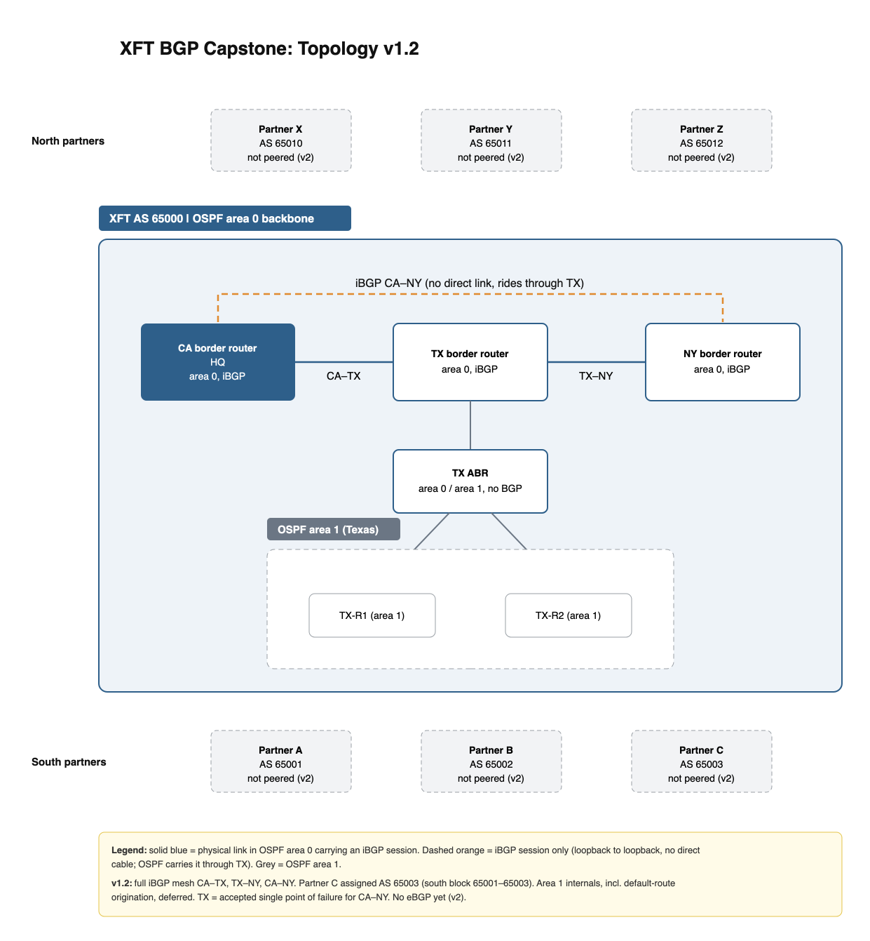
Figure 1: XFT topology v1.2.

Version 2.0
XFT adds a site in Oklahoma (OK) as the partner edge. OK hosts the border routers b1 and b2, which run eBGP to every partner (each partner peers with both) and iBGP to the site routers. OK has a link to each site: CA, TX and NY. The CA, TX and NY routers become site routers that run iBGP only. iBGP is a full mesh among b1, b2, CA, TX and NY (10 sessions).
- OK is the single exit for all partner traffic; losing OK cuts off every partner. Accepted for v2.
- The OK links give CA and NY a path that avoids TX, removing the v1 single point of failure at TX for internal traffic.
- Route reflectors, planned for OK, replace the full mesh as sites are added.
- Future: transatlantic long-haul links and more data centers.
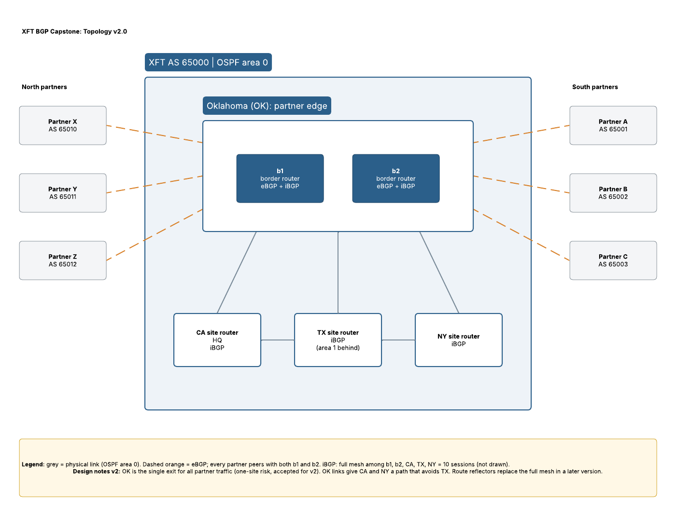
Figure 2: XFT topology v2.0.

Nov 3 brainstorm: decisions and open problems
XFT stays a multihomed non-transit AS in v2: b1 and b2 advertise only XFT's own prefixes to partners.
Decisions
- Outbound prefix list on all 12 eBGP sessions (6 partners × b1, b2) permits only XFT prefixes; the implicit deny drops partner routes.
- Intended state lives in YAML in Git, reviewed through pull requests; the generator builds every neighbor from one list and always attaches the policy.
- After each push, software compares each session's advertised routes against the YAML, and keeps rechecking on a schedule.
- Partner ASes (A, B, C, X, Y, Z) each get their own design: owned prefixes, transit or stub.
- Two route reflectors, both in Oklahoma: ok-core-000 plus a second core router.
- 8 clients: b1, b2, the CA, TX and NY site routers, and the three ABRs. The two reflectors peer as non-clients. Total 17 iBGP sessions, versus 45 for a full mesh of all ten routers.
- Migration: bring up client sessions to the reflectors, confirm routes, then remove old mesh sessions one at a time.
Open problems
- ☒ OSPF-only routers (ok-core-000, the ABRs) black-hole partner traffic: they have no route for partner prefixes. Making them RR clients fixes this.
- ☐ Both reflectors in Oklahoma: accepted risk, same as b1 and b2. A second site is future work.
- ☐ Name the second core router.
- ☐ Define XFT's own prefixes for the permit line.
- ☐ Study BGP confederations as an alternative to route reflectors.

Nov 7 brainstorm: how department routers reach partners
Decision: site ABRs stay RR clients with the full partner table, and each department area is totally stubby, so department routers get one default to their ABR.
- A conditional default from b1 and b2 (no BGP on the ABRs) was considered and rejected; trade-off recorded in the Department areas section.
- One ABR per site replaces one ABR per area, to keep the BGP session count flat as departments grow.
Open problems added
- ☐ Cable and address the second route reflector (links, interfaces, loopback).
- ☐ Design the routers and links inside each department area.
- ☐ Lab test: confirm a department router's only route out is the ABR's default (show ip route should show just intra-area routes plus 0.0.0.0/0).

